Major Project:
Title:
- Predictive and Adaptive Routing with Cost-Aware Cluster Maintenance in SDN-Enabled Vehicular Ad Hoc Networks

- Mobility-Aware Predictive Routing and Dynamic Cluster Maintenance for SDN-Based Vehicular Ad Hoc Networks.

- Adaptive Route Maintenance and Mobility-Aware Clustering for Reliable SDN-Enabled Vehicular Networks.

Problem Statement:

Objectives:
1 — To Design and Develop the baseline SDN-VANET routing framework
To implement and evaluate the fundamental components of the HARNES-based SDN-enabled VANET architecture, including hierarchical controllers, vehicle clustering, cluster-head selection, link reliability estimation, and heuristic route discovery.
2 — Evaluate the proposed framework under dynamic VANET conditions
To compare the proposed approach with existing routing mechanisms under varying vehicle densities, mobility patterns, and network conditions using metrics such as route stability, route-break frequency, routing overhead, re-clustering frequency, computation time, path length, and packet-level performance where applicable.
3— To design and develop a predictive Stability- Aware Clustering algorithm with Cost-Aware Cluster Maintenance
Predictive Stability-Aware Clustering with Cost-Aware Cluster Maintenance
To develop a predictive and stability-aware Cluster Head selection mechanism that reduces unnecessary CH changes and improves cluster lifetime and routing stability.
4 — To extend the proposed clustering algorithm to predict links and route stability estimation for optimal route selection and maintenance
To estimate the future lifetime of vehicle-to-vehicle communication links using vehicle mobility information such as relative position, velocity, and communication range, and subsequently estimate the expected lifetime of complete communication routes.
5—
To incorporate predicted route stability into route selection and develop a proactive local route repair mechanism that identifies potentially failing routes and attempts on alternative paths before complete route disconnection occurs.

Project related content:
1. Vehicle information
↓
2. Topology construction
↓
3. Reliable paths
↓
4. Betweenness Centrality
↓
5.Select Cluster Heads
↓
6.Create clusters
↓
7.LEC/GEC routing
↓
8.Theta* / D*-Lite

Novelty: Predictive Stability-Aware Clustering with Cost-Aware Cluster Maintenance:
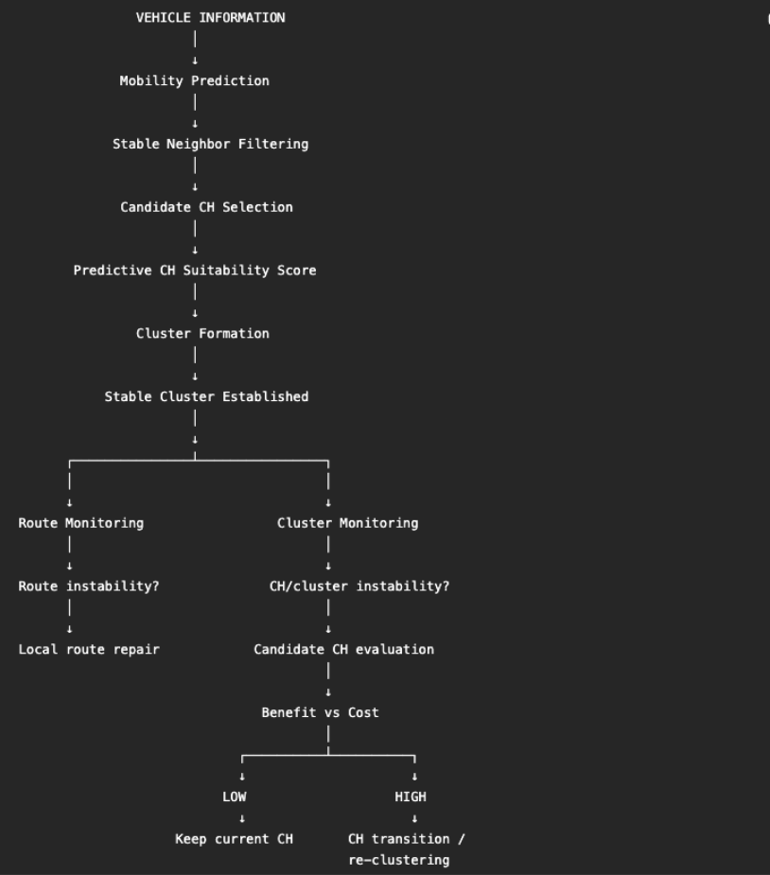

Cluster Creation:
1. Build the neighbor table
2. Predict link lifetime
3. Filter unstable neighbors
4. Form clusters around stable candidates
Step B: Cluster Head Selection:
1. Our CH candidate score
1.1. Current Connectivity
How many stable neighbors does it have?
1.2. Betweenness Centrality
1.3. Mobility compatibility
How similar is the vehicle moving compared with its neighbors?
1.4. Predicted link lifetime
How long are the important links expected to survive?
1.5. Predicted cluster lifetime
2. CH switching hysteresis
Score_new > Score_current + Δ

Step C: Cluster Maintenance:
1. Level 1 — Do nothing
2. Level 2 — Local CH/member adjustment
Move member
OR
switch CH
OR
use candidate CH
3. Level 3 — Full re-clustering
cluster seriously unstable
AND
local repair insufficient
AND
benefit > cost
So how do we actually calculate stability?
We can construct a Cluster Stability Score.
For example:
$SC​=w1​LC​+w2​MC​+w3​ConnC​+w4​CHC​$
where:
- LC_C = normalized predicted link stability
- M_C = mobility stability
- Conn_C = connectivity stability
- CH_C = predicted CH stability
with:
w1​+w2​+w3​+w4​=1

How do we calculate CH suitability?
We can combine several normalized factors.
For candidate vehicle ii:
CHScorei =$w1​BCi​+w2​Conni​+w3​Mobi​+w4​LTi​+w5​CLTi​$
where:
- BC_i = Betweenness Centrality
- Conn_i = connectivity
- Mobi_i = mobility stability
- LT_i = predicted link lifetime
- CLT_i = predicted cluster lifetime

BENEFIT
Suppose our current CH is CH1.
We consider replacing it with CH2.
We create a hypothetical candidate configuration internally at the controller.
We ask:
“If CH2 becomes the CH, what improvement do we expect?”
We can measure several things.

Example
Current configuration:
$CLcurrent​=4.0s$
Candidate configuration:
$CLnew​=7.0s$
Then the cluster-lifetime improvement is:
$BCL​=\frac{7-4}{4}​=0.75$
So that's a 75% relative improvement.
Similarly, suppose route lifetime changes:
$RLcurrent​=3s$
$RLnew​=5s$
Then:
$BRL​=\frac{5-3}{3}​=0.667$
And suppose predicted future failures decrease:
$Fcurrent​=6$
$Fcurrent= 3$
Then:
$BF​=\frac{6-3}{3}=0.5$
We combine these:
For example, if:
η1=0.4,η2=0.4,η3=0.2\eta_1=0.4,\quad \eta_2=0.4,\quad \eta_3=0.2
Then: $Benefit=η1​BCL​+η2​BRL​+η3​BF​$

Benefit=0.4(0.75)+0.4(0.667)+0.2(0.5)Benefit= 0.4(0.75)+0.4(0.667)+0.2(0.5) Benefit≈0.667Benefit\approx0.667
So the candidate configuration gives approximately 0.667 normalized benefit.

reconfiguration COST
This is where our project becomes interesting.
Changing CHs isn't free.
We may have:

Communication cost
Messages required for:
- CH announcement
- membership updates
- topology information
- route updates
Represent this as: C_{msg}

Computational cost
The controller has to:
- process mobility information
- evaluate candidate CHs
- calculate stability
- construct hypothetical configurations
Represent this as: C_{comp}
Reconfiguration/transition cost
Actual:
- CH switching
- member reassociation
- route modification
- re-clustering
Represent this as: C_{trans}
Then:
$Costrecluster​=η4​Cmsg+η5​Ccomp​+η6​Ctrans$
Again, these should be normalized before combining them.
Finally: $Benefit>Cost+τ$
If yes: reclustering
Otherwise : keep the structure.

Component | Already exists? | Can we call it our novelty?
Mobility prediction | ✅ | ❌
Link lifetime prediction | ✅ | ❌
Stability-aware CH selection | ✅ | ❌
Predictive clustering | ✅ | ❌
Adaptive route maintenance | ✅ | ❌
Hysteresis-based switching | ✅ | ❌
SDN-based VANET routing | ✅ | ❌
Cost/overhead consideration | ✅ in various forms | ❌ by itself
Benefit-vs-reconfiguration-cost decision integrated into HARNES maintenance | Needs careful literature verification | Potential contribution
Unified clustering-maintenance + routing feedback decision framework | Needs careful comparison | Potential contribution

Ref Links:
https://pmc.ncbi.nlm.nih.gov/articles/PMC13230870/
https://www.sciencedirect.com/science/article/pii/S138912862300405X

Title:

Predictive and Adaptive Routing with Cost-Aware Cluster Maintenance in SDN-Enabled Vehicular Ad Hoc Networks
Problem Statement:
To design and develop a SDN framework to improve the stability and efficiency of routing in highly dynamic VANETs by addressing frequent route and cluster changes caused by vehicle mobility, while minimizing the overhead associated with unnecessary Cluster Head switching and re-clustering.

Objectives:

- To understand the baseline SDN-VANET routing framework
- To design and develop a predictive Stability- Aware Clustering algorithm with Cost-Aware Cluster Maintenance
- To extend the proposed clustering algorithm to predict links and route stability estimation for optimal route selection and maintenance
- Evaluate the proposed framework under dynamic VANET conditions

